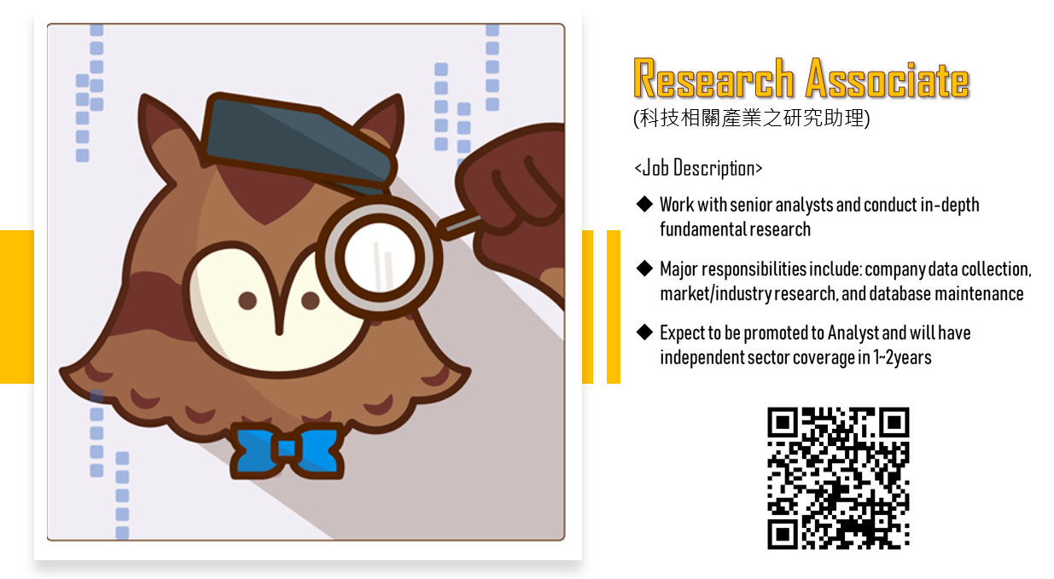
【企業簡介】
TAROBO (www.taroboadvisors.com) 是台灣本土 FinTech 新創平台，由多位出身於台大，專精金融投資與量化模型的校友共同創辦，目標打造國際級的智能基金投資服務，成為台灣的基金投資人最好的選擇。TAROBO 結合專業的投研人才與技術人才，真正做到 Fin + Tech，加上創意滿點的網站製作小組，將複雜的金融數據資訊，轉化為清晰易懂的介面。我們正在走沒有人走過的路，如果你對自己的專業執著，願意投入、不怕嘗試、不怕犯錯、更超熱愛在過程中學習、成長、那歡迎你加入與我們並肩作戰！

Research Associate(科技相關產業之研究助理)
<Job Description>
1. Work with senior analysts and conduct in-depth fundamental research
2. Major responsibilities include: company data collection, market/industry research, and database maintenance
3. Expect to be promoted to Analyst and will have independent sector coverage in 1~2years

Qualifications:
1. Really interested in investment & research
2. Be able to work extended hours and work well under pressure
3. Good team player with strong communication skill, detail-oriented personality, and self-motivated attitude
4. Education: Bachelor/Master degree in Business management, Finance, or Electrical Engineering is required
5. Language: Fluent in English, oversea background is a plus
6. Minimum 1 years work experience preferred
7. Office productivity applications: Excel and database (TEJ, Wind, Bloomberg)

科系：電機電子工程相關 ,一般商業學類
工作經驗：1年以上
薪資範圍：面議
應徵方式：請將履歷表投遞至alison.tsai@taroboadvisors.com

