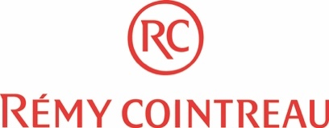
Job Description
Job Title: Management Trainee – Digital marketing
Direct Report: Managing Director – Hong Kong & Taiwan
Based in: Taipei

MT Program Background:

- The 1-year program is specially designed for all 2019 university graduates
- Focus on the different roles in his/her own Functional Business
- One on One Mentor, mentor, coaching and evaluating to help you grow
- Various Training program both on professional skills and functional skills
- Provide opportunity to participate in critical projects and work as a project team
- Career development opportunities will be provided based on the performance and potential

Job Description:
- Update / populate our web pages, ensuring a continuous feed of new and digital content and alignment of content direction across all digital platforms
- Develop and execute digital content and related projects: newsletter, portal, videos, digital totems
- Repackage existing content into format suitable for social media platforms
- Assist in the development of marketing tools to drive the visibility of our various business lines
- Assist in the design, implementation and marketing of client events linked to Tech / Innovation / Digital Trends in Asia
- Keep up to date with digital trends
- Research, develop, and implement new innovative digital tools: webinars, apps, and podcasts
- Actively participate in content creation, planning and dissemination
- Hands-on knowledge of image, artwork and video-editing softwares, including Adobe Photoshop, InDesign and Premiere. InDesign, Illustrator, Graphic Design, Movie Maker
- Measure the return on our campaigns

Requirements
- Only for fresh graduate , bachelor degree is the minimum;
- Major in marketing/business management/ Economy/ International trade / Digital
- Excellent presentation skill and language ability (in both Mandarin and English); French is a plus.
- Strong ability to grasp new knowledge
- Good interpersonal, negotiation skills and team-player, proactive, under pressure, dedication.
- Good personality and interpersonal communication skills.
- Enjoys achievement, personal growth and rapid changing environment
- Strong motivation to achieve a big success and work under pressure and tight deadlines
- Excellent computer skills especially on PPT and Excel.

Others
- Self- motivated
- A Team player

