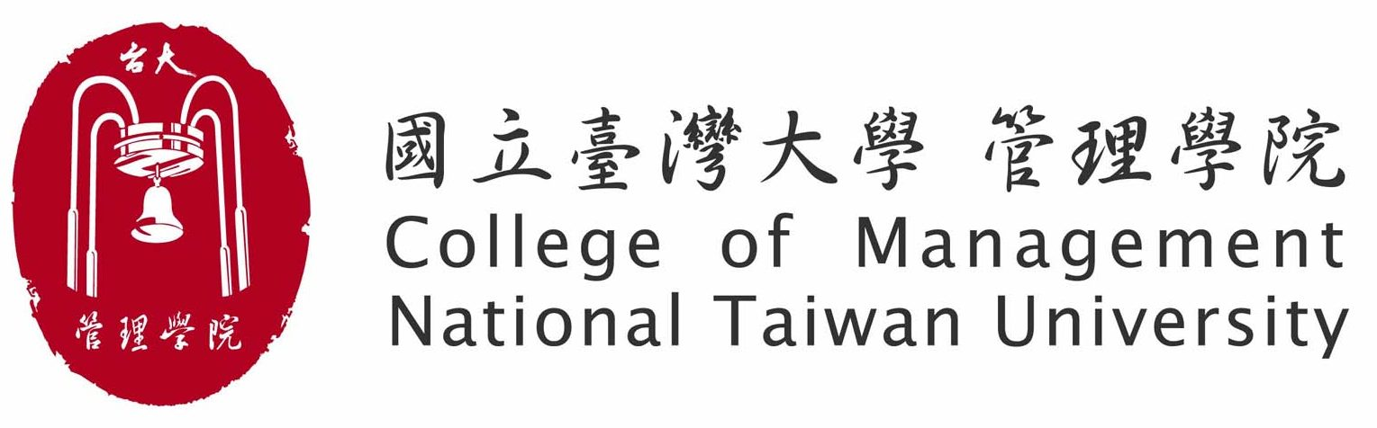
Office Use Only

Date Received

2024-2025 CoM of NTU and PKU Guanghua Double Degree Program
Application Form
Please use TYPESCRIPT to fill out this form and tick boxes as appropriate.
1. Personal Information
Full Name in English (as shown on your passport)
(Given Names) (Surname/Family Name)
Full Name in Chinese

Date of Birth  __ __/ __ __ /__ __ __ __ (Month/Day/Year) | Gender  □ Male □ Female
Nationality
2. Contact Information
Telephone |  | Mobile Phone
E-mail 1  @ |  | E-mail 2  @
3. Academic Information
Student ID Number |  |  | Department □ ACC □ BA □ FIN  □ IB □ IM □ GMBA
I am in my of study. □ 1st year □ 2nd year □ Other, _______________________
My average GPA is ____________ (for example: 3.76) (The average GPA is required to be 3.0 or higher.)
I would like to apply one of the following programs in PKU.
□ GMBA (taught in English)
□ PMBA (taught in Chinese)
4. Language Assessment
(1) GMAT Score: _____________ or GRE Score: ____________
(2) Other: _____________

Applicant’s Declaration
I hereby confirm I have read the 2024-2025 CoM of NTU and PKU Guanghua School of Management
MBA Double Degree Program Application Guideline, the information provided and submitted with this application is correct and complete.
我已詳閱【113學年度臺灣大學管理學院與北京大學光華管理學院MBA雙聯學位計畫甄選簡章】，並確認提交的申請資料內容屬實且完備。
Application materials check
□ 1. Application Form (this form)
□ 2. Personal Statement
□ 3. Curriculum Vitae/Resume
□ 4. Official Transcript of Grades (English Version)
□ 5. Photocopy of effective language certificate
Applicant’s Signature（申請人簽名）
_______________________________________________ Date: (mm) (dd) (yyyy)

